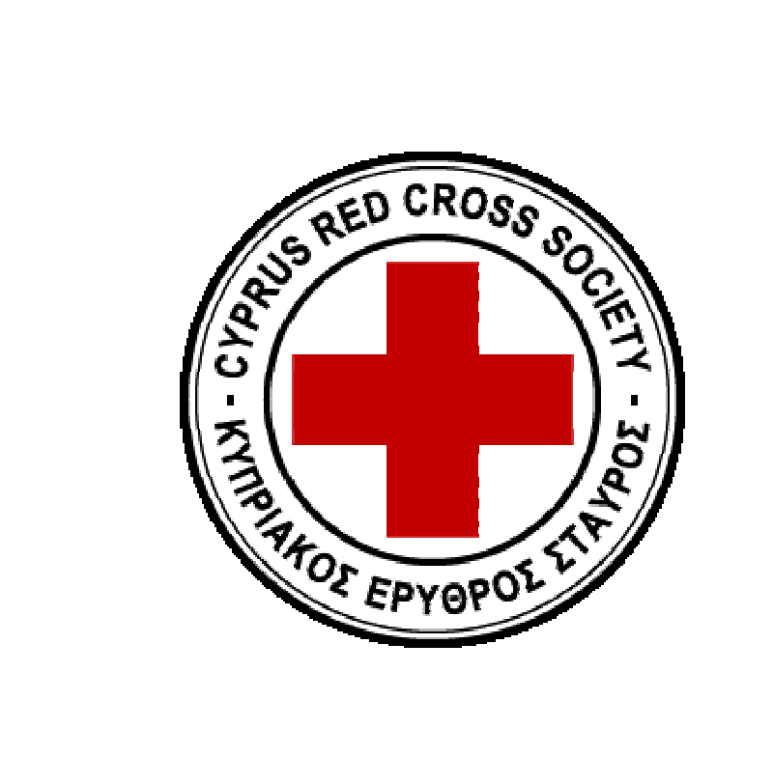
Cyprus Red Cross Society
Psychosocial Support Program

Community Based Psychosocial Support Training

Participant's Registration Form

Please complete the following and return to the address given below before 24/10/2015

Name/ Surname:

Phone number:

Email:

Age:

Sex:

Training language:

English:

Greek:

Educational Background:

Cyprus Red Cross Society
Psychosocial Support

Experience working in the field of psychosocial support and/or other related areas:
Please note that this is not a pre-requisite to the training workshop.

Experience with the International Red Cross Red Crescent Movement:
Please note that this is not a pre-requisite to the training workshop.
Expectations of the training workshop:

Issues you would like to see addressed in the workshop:

Limited number of participation.

Please return the completed form at the address given below before the 24th of October at the following email address: reliefcoord@redcross.org.cy

